 

**Assignment – 3**

|  |  |
| --- | --- |
| **Student Name/ID Number:** | Wildan Luqmanul Hakim/BDSE04-0322 |
| **Academic Year:** | 2022 |
| **Unit Assessor:** | Arvinder Kaur |
| **Project Title:** | Assignment 3– Spring Boot |
| **Issue Date:** | 25 November 2022 |
| **Submission Date:** | 28 November 2022 |
| **Internal Verifier Name:** |  |
| **Date:** | 28 November 2022 |

|  |
| --- |
| **Learner declaration** |
| I certify that the work submitted for this assignment is my own and research sources are fully acknowledged.    Student signature: Date: 28 November 2022 |

|  |  |  |  |  |  |
| --- | --- | --- | --- | --- | --- |
| **Module No:** | 1 | **IU No:** | 3 | **Exercise No.** | 1 |

|  |  |
| --- | --- |
| **Lab Assessment Statement** | **Assignment 4 - Spring Boot**  **Let’s build on the previous assignment.**   1. **Create a Spring Boot application for “Know-Your-Neighborhood”.** 2. **Add support for JSP views and create required folder structure.** 3. **Move already developed classes into this project.** 4. **Develop all components required to view the stores**    1. **Add method to existing Controller class to receive the request to fetch stores**    2. **Add method to existing Service class to process the request (or add method to existing service class)**    3. **Add method existing repository class to return all available stores.**    4. **Create HTML to view the stores. Show name, phone number and localities it serves for each store.**    5. **Ensure that view stores request works end-to-end. (i.e., should be able to submit request to view the stores in the browser and get the page back with all stores).** 5. **Create an HTML page to add a store and link it to the view stores page.** 6. **Let the response of add request submission be the view page that shows all stores including recently added store.** |
| **Technical Environment** | - |
| **Guidelines** | - |
| **Duration** | 120 mins |

**Let’s build on the previous assignment.**

1. **Create a Spring Boot application for “Know-Your-Neighborhood”.(Project making)  
   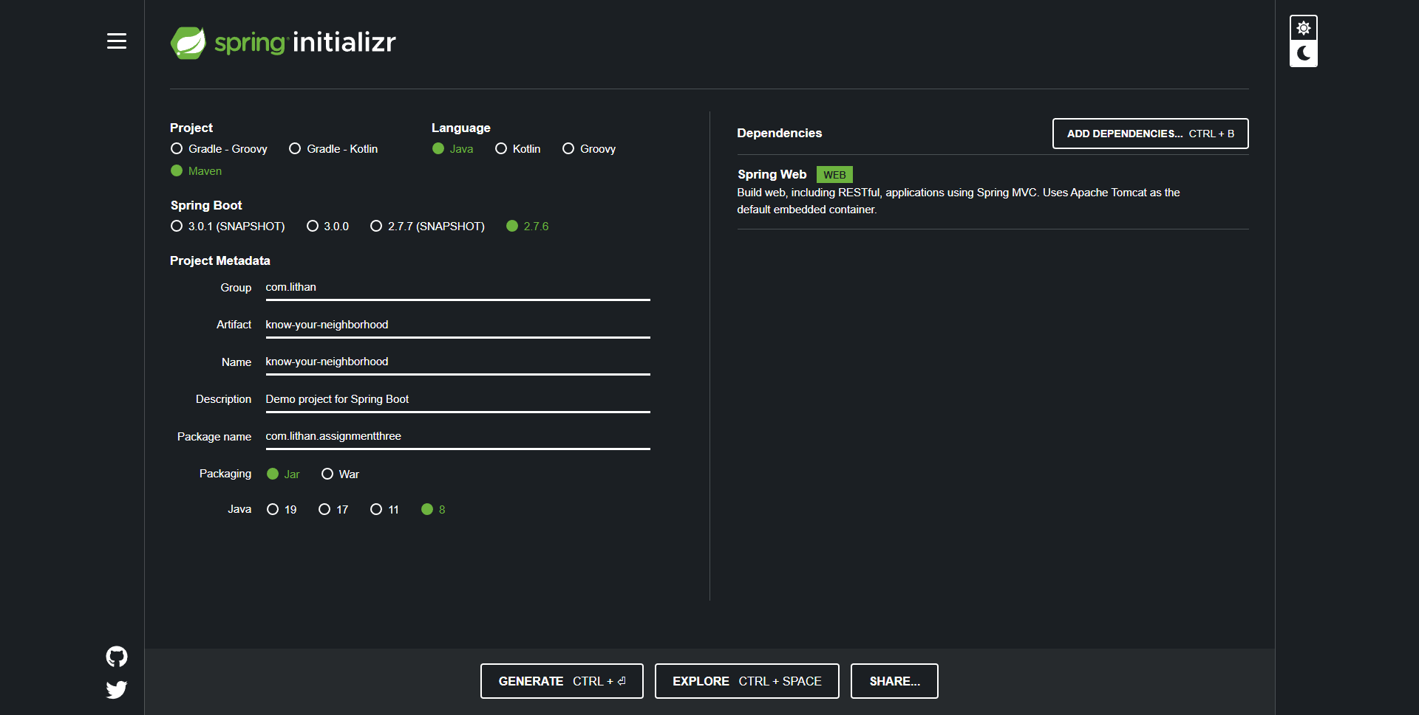**
2. **Add support for JSP views and create required folder structure. ”.(Project making)  
   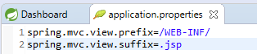**
3. **Move already developed classes into this project. ”.(Project making)  
   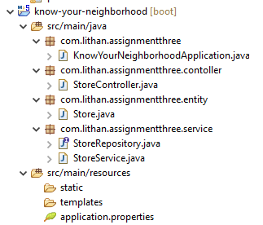**
4. **Develop all components required to view the stores**
   1. **Add method to existing Controller class to receive the request to fetch stores   
      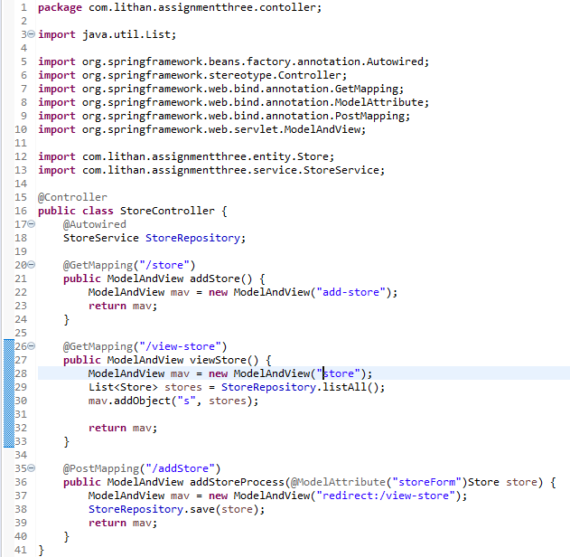**
   2. **Add method to existing Service class to process the request (or add method to existing service class)  
      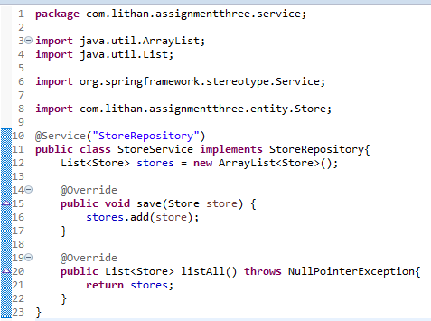**
   3. **Add method existing repository class to return all available stores.  
      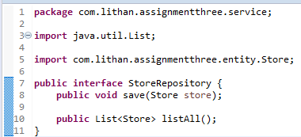**
   4. **Create HTML to view the stores. Show name, phone number and localities it serves for each store.  
      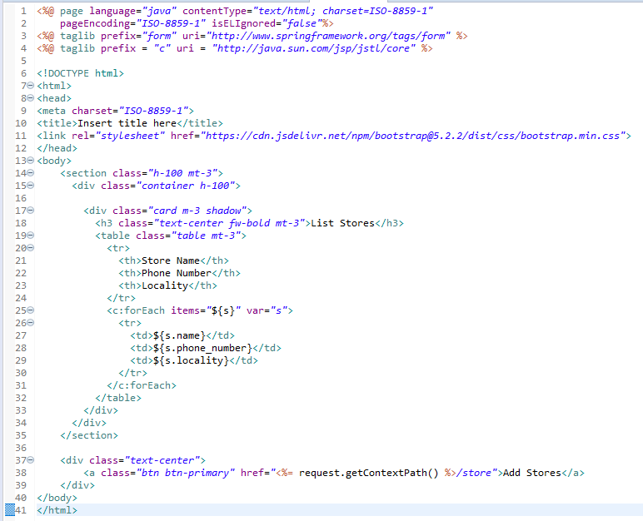**
   5. **Ensure that view stores request works end-to-end. (i.e., should be able to submit request to view the stores in the browser and get the page back with all stores).  
      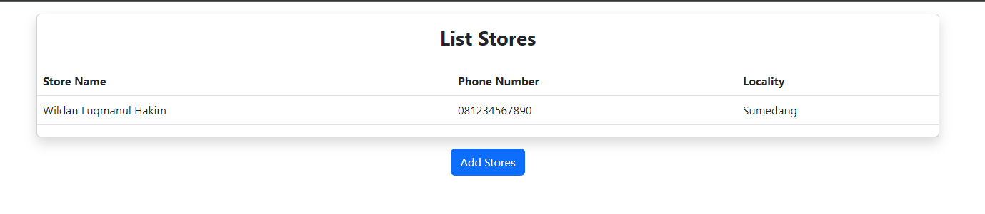**
5. **Create an HTML page to add a store and link it to the view stores page.  
   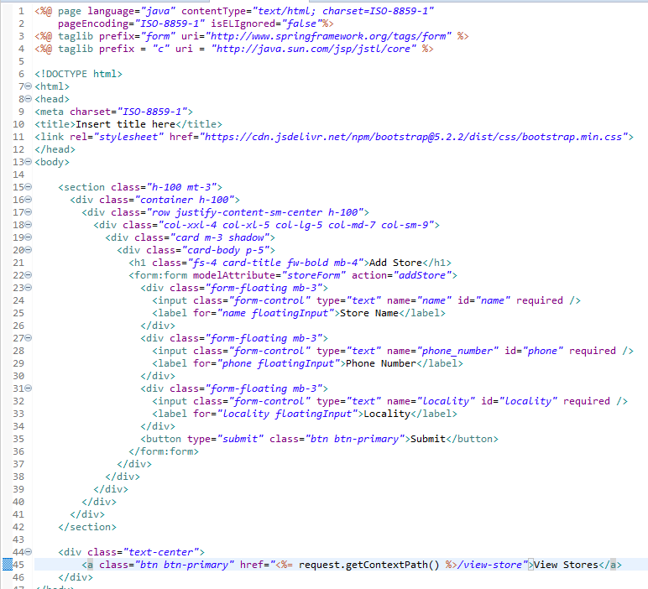**

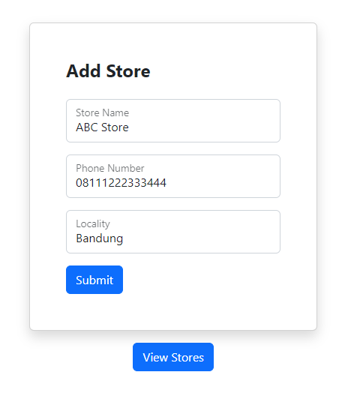

1. **Let the response of add request submission be the view page that shows all stores including recently added store.  
   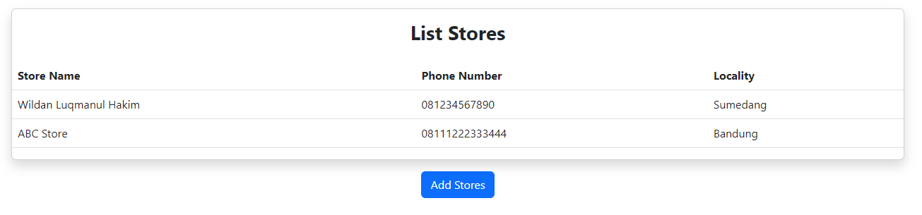**

**Source Code :  
**